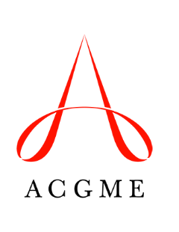
ACGME Coordinator Advisory Group
Disclosure Form

This form must be completed and signed by the nominee.

- I confirm that I am not employed by the ACGME.
- I confirm that I am not related to anyone who is employed by the ACGME.
- I have no financial or non-financial relationships with the ACGME to report.
- I have the following financial and/or non-financial relationship(s) to report:

__________________________________________________ _______________________
Nominee’s Name (please print) Date

__________________________________________________
Nominee’s Signature (electronic signatures are acceptable)

