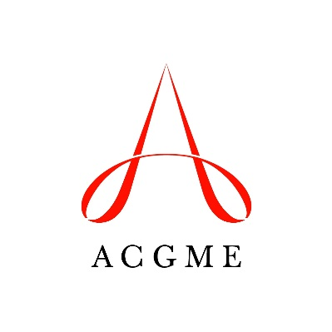
Self-Study Summary of Achievements
Accreditation Council for Graduate Medical Education

Use this template to describe the strengths of your program, and the improvement outcomes that were achieved in areas identified during your self-study 12 to 18 months ago.

Please answer narrative Questions 1-6.
The summary of achievements must be completed and uploaded through the Accreditation Data System a minimum of 12 days before the date of the 10-year accreditation site visit.
Programs with changes in the information related to their aims or environmental context (opportunities and threats facing the program) may also submit a self-study summary update before their 10-year accreditation site visit (link to SS Summary Update).

Notes:
The updated information will be used to assess the effectiveness of the program’s self-study in promoting achievement in areas important to the program’s aims and environmental context.

Program Strengths
Question 1: List the program’s key strengths that were identified during the self-study. (Maximum 250 words)

Question 2: Discuss how these strengths relate to the program’s aims. (Maximum 200 words)

Question 3: Discuss how these strengths relate to the program’s context; e.g., capitalize on program opportunities, or mitigate threats facing the program. (Maximum 200 words)

Achievements in Program Self-Identified Areas for Improvement
Question 4: Describe improvements in critical areas that were identified during the self-study. (Maximum 250 words)

Question 5: Discuss how these improvements relate to the program’s aims. (Maximum 250 words)

Question 6: Discuss how these improvements relate to the program’s context; e.g., capitalize on program opportunities, or mitigate threats facing the program. (Maximum 250 words)

Question 7: Summarize the process for how the program made these improvements, and what information was used to track progress, and to assess the improved outcomes. (Maximum 250 words)

OPTIONAL Question 8: Summarize any learning for the program that occurred during the process of making improvements as a result of the self-study. (Maximum 200 words)

