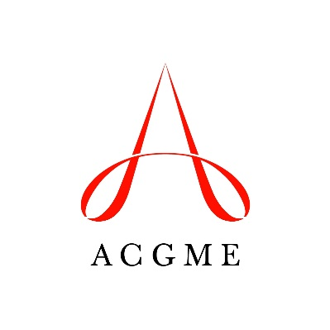
Self-Study Summary
(Short Version for Subspecialty Programs)
Accreditation Council for Graduate Medical Education

Use this template for aggregating information from the self-study for submission to the ACGME. This form is optional for use with subspecialty programs. Program may choose to use this form, or the longer standard form.

After completing the self-study, answer narrative Questions 1-6.
The deadline for uploading the self-study summary is the last day of the month the Review Committee indicated for the program’s first site visit in the Next Accreditation System. (For example, if the Review Committee indicated July 2016 as the date of the first site visit, the document must be uploaded by July 31, 2016.)

Notes:
The documents will be used to assess the program’s aims and environmental context, as well as the process used for the self-study and how this facilitates program improvement.
Do NOT provide information on areas for improvement identified during the self-study. A separate document to be submitted 12 to 18 months after initiating your self-study will request information on improvements realized in areas identified in the self-study.
The materials provided for the self-study include a blank Annual Program Evaluation Summary (AnnualEvalSummary.doc), and a form for tracking action plans across successive Annual Program Evaluations (AnnualEvalLongitudinal.doc). You are not required to use these forms, and may instead develop your own or adapt other existing forms.

Program Description and Aims
Describe the program and its aims, using information gathered during the self-study.
Question 1: Program description and aims
Provide a brief description of your residency/fellowship program, as you would to an applicant or a prospective faculty member. (Maximum 200 words)

Question 2: Program activities to advance the aims
Discuss the subspecialty program’s aims, and current activities to further these aims. (Maximum 250 words)

Environmental Context
Summarize the information on the program’s environmental context that was gathered and discussed during the self-study.
Question 3: Opportunities for the program
Based on the information gathered and discussions during the self-study, what are important opportunities for this program? (Maximum 250 words)

Question 4: Threats facing the program
Based on the information gathered and discussions during the self-study, what are real or potential significant threats facing this program? (Maximum 250 words)

Annual Program Evaluation and Self-Study Process
Provide a brief description of the process for the Annual Program Evaluation, including action plan tracking, and the self-study process for this program.
Question 5: Self-study process
Provide information on your subspecialty program’s self-study, including who was involved, how data were collected and assessed, how conclusions were reached, and any other relevant information. (Maximum 250 words)
OPTIONAL Question 6: Learning that occurred during the self-study
Describe any learning that occurred as a result of the program’s self-study. The ACGME intends to use this information to identify best practices for conducting a self-study for dissemination to the medical education community. (Maximum 250 words)

