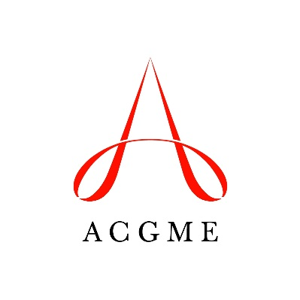
Self-Study Summary Update
Accreditation Council for Graduate Medical Education

Use this template to provide updated information to the self-study summary that has been submitted to the ACGME. Updated information may be provided at two times: 1) immediately before the 10-year accreditation site visit (all programs); and 2) after the program has complete the voluntary self-study pilot visit (only programs that participate in the voluntary pilot visit). Programs with a self-study pilot visit may provide an update at both times.

Before the 10-Year Accreditation Site Visit
When provided immediately before the program’s 10-year accreditation site visit (12 to 18 months after the self-study was conducted and the original summary was submitted), the updated summary must be completed and uploaded through the Accreditation Data System a minimum of 12 days before the date of the 10-year accreditation site visit.
Programs without any changes in the information related to their self-study do not need to submit an update before their 10-year accreditation site visit. These programs only need to complete the self-study summary of achievements (link to SS Achievement Summary).

After the Self-Study Pilot Visit
Programs that participate in the self-study pilot visit may submit updated information immediately after the pilot visit, if the visit identified additional information that the program wants to include in its summary.
For a program with a self-study pilot visit, the updated summary needs to be completed within 30 days of the pilot visit.

Notes:
The updated information will be used to assess the program’s aims and environmental context, as well as the process used for the self-study and how this facilitates program improvement.

Program Description and Aims
Describe any changes to your description of the program and its aims.
Question 1: Changes in the Program description (Maximum 200 words)

Question 2: Changes in Program aims (Maximum 150 words)

Question 3: Program activities to advance the aims
Any new activities or changes in existing activities to promote or further program aims. (Maximum 250 words)

Environmental Context
Describe any changes in the program’s environmental context since the self-study was conducted.
Question 4: Changes in Opportunities for the program (Maximum 250 words)

Question 5: Changes in Threats facing the program (Maximum 250 words)

Question 6 (OPTIONAL): Learning that occurred after the self-study
Describe any learning that occurred as a result of the program’s self-study. The ACGME intends to use this information to identify best practices for conducting a self-study for dissemination to the medical education community. (Maximum 250 words)

