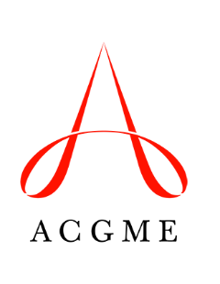

Institutional Self-Study Summary Form

After completing the Institutional Self-Study, provide responses to the questions below.

Sponsoring Institution Name:
ACGME 10-Digit ID:
Self-Study Date (Month and Year):

Reviewed and approved by:

__________________________________________ __________________
Printed Name: Date
Representative of Sponsoring Institution’s Senior Administration

__________________________________________ __________________
Printed Name: Date
Representative of Sponsoring Institution’s Governing Body

By signing the Institutional Self-Study form, the designated institutional official attests that the completed form has been reviewed and approved by the Graduate Medical Education Committee.

__________________________________________ __________________
Printed Name: Date
Designated Institutional Official

Question 1: Institutional Self-Study Team
Who was included in the Institutional Self-Study team and why? List by name, role, and title. (Maximum 300 words.)
Question 2: Sponsoring Institution Mission
State the Sponsoring Institution’s graduate medical education (GME) mission. (Maximum 250 words.)
Question 3: Opportunities for the Sponsoring Institution
Describe important opportunities for the Sponsoring Institution. (Include information gathered for the Institutional Self-Study, and the Institutional Self-Study team’s analysis of institutional performance, to discuss the Sponsoring Institution’s environmental context. Maximum 250 words.)
Question 4: Threats Facing the Sponsoring Institution
Describe real or potential challenges that may affect the Sponsoring Institution’s ability to achieve its aims. (Maximum 250 words.)
Question 5: Sponsoring Institution Aims
Describe three to five aims related to the Sponsoring Institution’s GME mission, and informed by the Institutional Self-Study team’s analysis. (Maximum 150 words.)
Question 6: Aims Linked to National Learning Community for Sponsoring Institutions
If applicable, identify any institutional aims that are aligned with the work of the ACGME’s national learning community for Sponsoring Institutions. (Maximum 200 words.)
Question 7: Advancing the Aims
Describe current resources, processes, activities, and/or policies that contribute to advancing these aims. (Maximum 250 words.)
Question 8: Sponsoring Institution Actions
Describe actions that the Sponsoring Institution will take over the next three to five years to achieve each aim. (Maximum 350 words)

