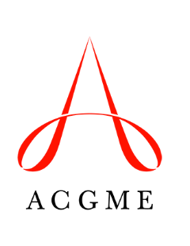
Self-Study Summary Update
Department of Accreditation, Recognition, and Field Activities

Use this template to update information in the Self-Study Summary submitted to the ACGME.

Before the 10-Year Accreditation Site Visit
Completing this Self-Study Summary Update is optional. It should be used to provide new information ahead of the 10-Year Accreditation Site Visit.

Updates can be made to: 1) identify changes in the program since the Self-Study Summary was submitted; and 2) provide information on new dimensions of the Self-Study added in April 2017.

The Self-Study Summary Update should be completed and uploaded through the Accreditation Data System prior to the 10-Year Accreditation Site Visit date. See the site visit announcement letter for the specific due date.

Programs must also complete the Self-Study Summary of Achievements.

Update 1: Updates/Changes to Information Provided in the Original Self-Study Summary
Use this part of the form to describe any changes or updates to the information that was submitted in the original Self-Study Summary. (Maximum 350 words)

Update 2: Share the vision and plans for the program for the coming five years. What will take this program to “the next level”?
Discuss what the “next level” will look like, the envisioned steps and activities to achieve it, and the resources needed. If the Self-Study Summary was submitted prior to April 2017, use this part of the form to provide information for areas that were added to the Self-Study Summary. (Maximum 350 words)

